Project 1 Report

CSCE 113-501

Alan, Jason, Chihyen

user names: alan76,jclinton, cyc2970

Banking System Interface:

* For the interface we chose to use a **switch statement** to allow the user to input the number of whichever operation they wished to perform.
* **Alan** wrote the classes and member functions used to perform these operations.
* **Chih-Yen** helped write the main function and the error handling code.
* **Jason** helped with some of the class definition testing and wrote the report.

Private Data:

* We chose **not to use private data** in order **to simplify** the program; this may lead to security issues.

Input/Output Error Handling:

* In order to catch bad input we used **try and catch blocks**.

C++ Object Oriented Features:

* We created a bank, and customer class to hold statistical data about the bank as well as customer information which is stored in a vector.
* We also used structs for transactions and statistics to format the data.

Testing Cases (w/ Screen Shots):

Upon running program, this is what appears first:

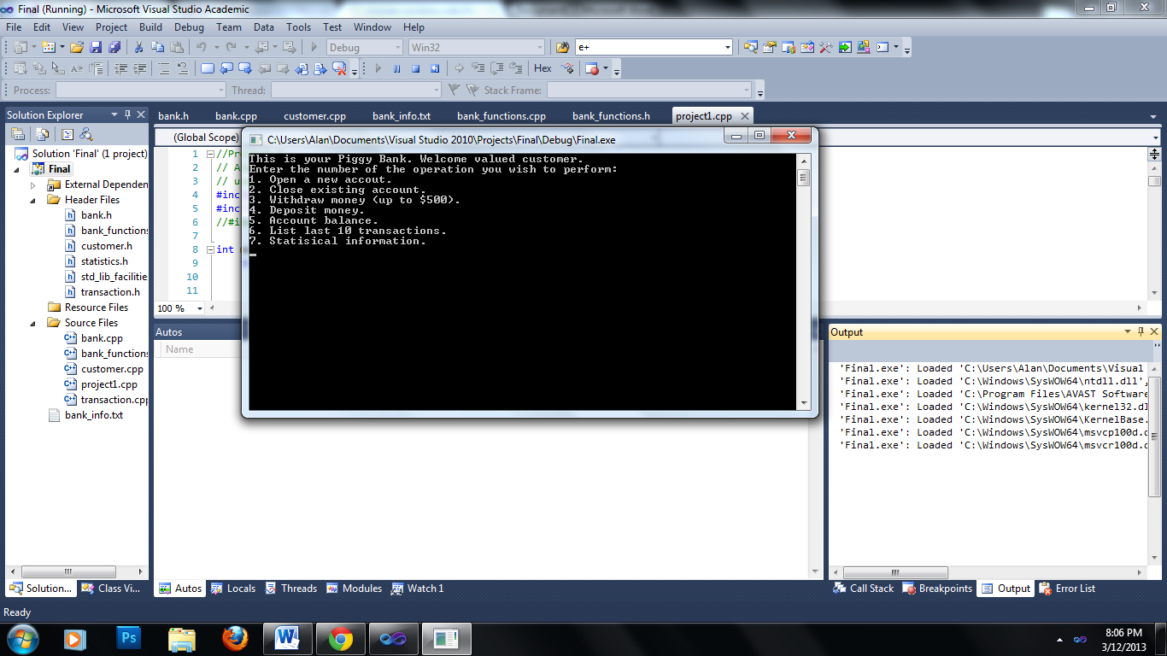

Next, to open a new account, you enter 1:

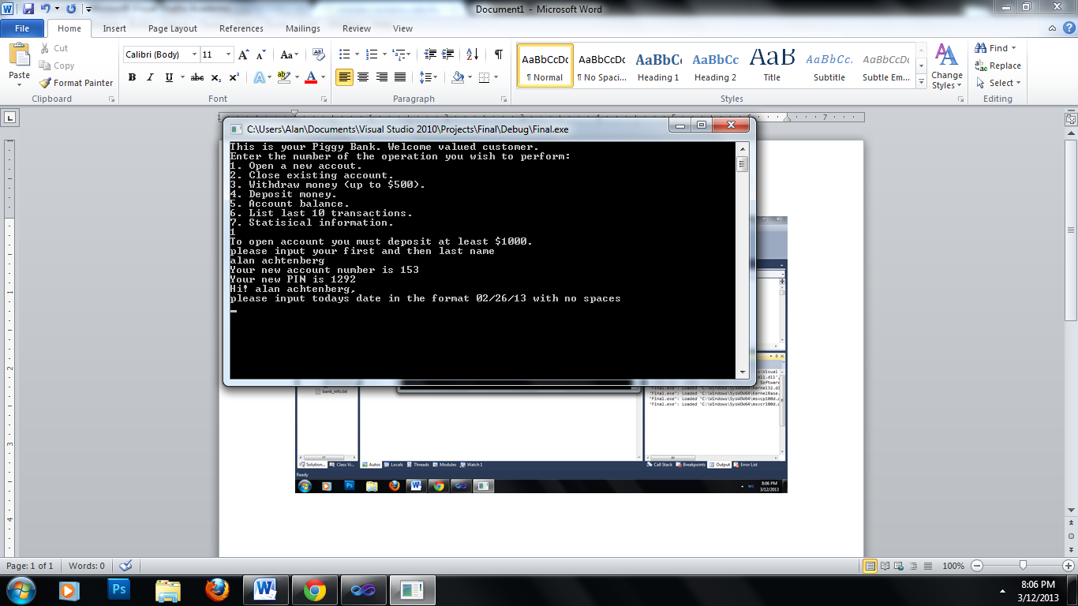

To close your account you enter 2 and then enter ‘y’ (to confirm).

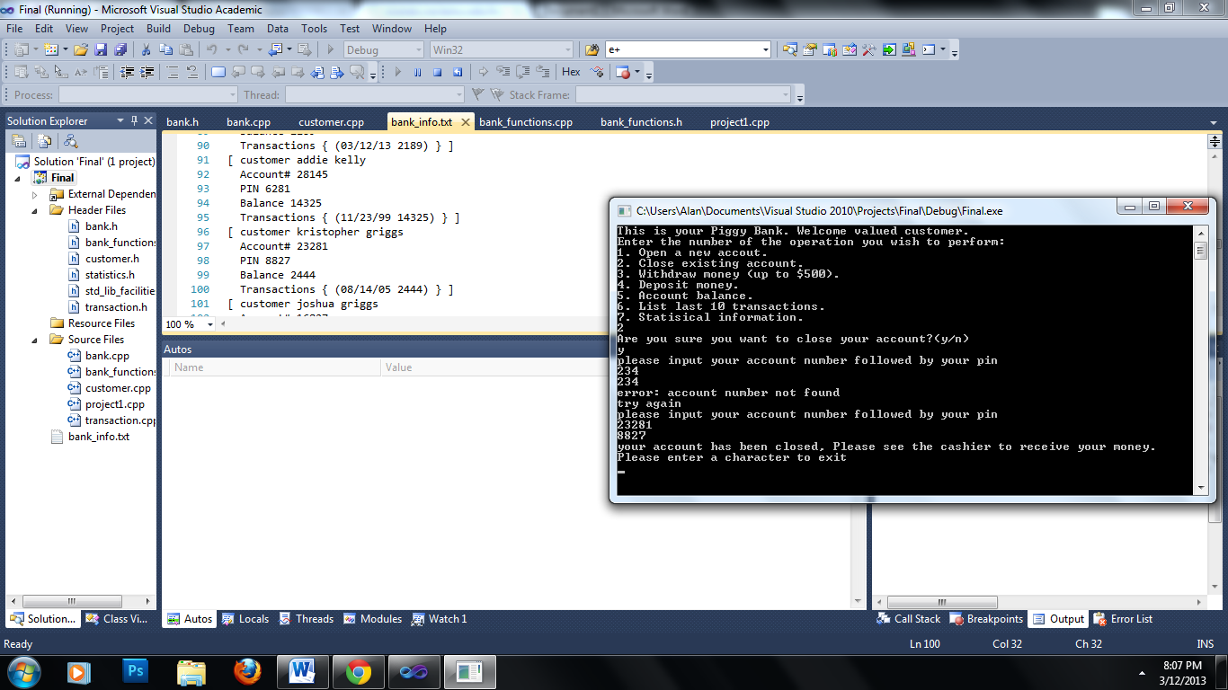

Option 3 allows you to withdraw money up to $500 dollars:

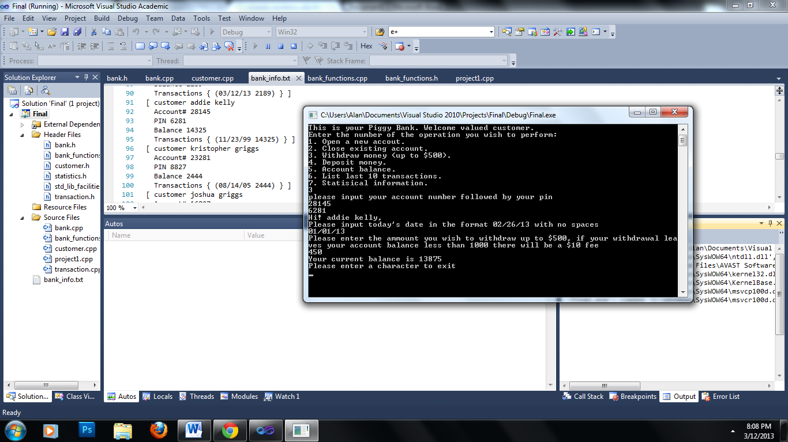

Option 4 allows you to deposit money:

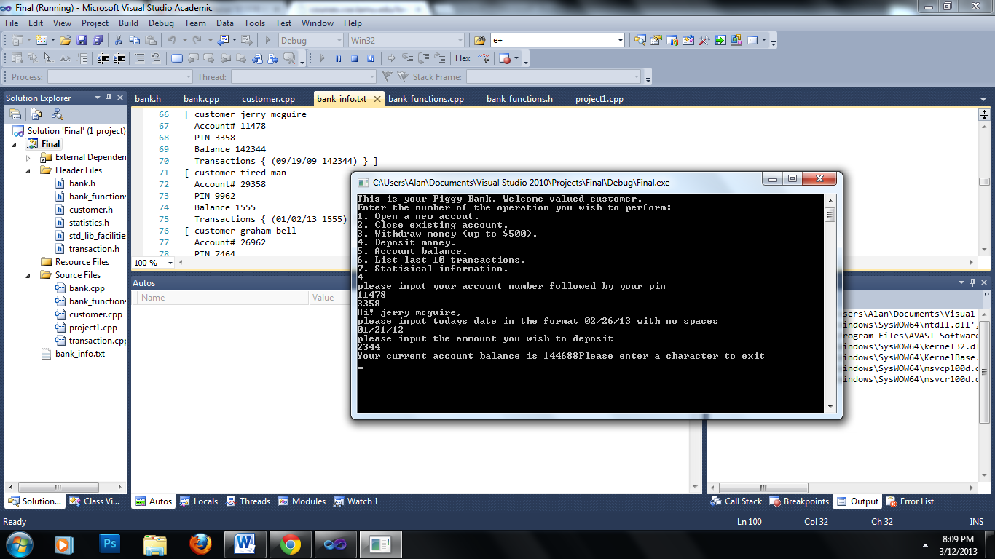

Option 5 allows you to view your account balance:

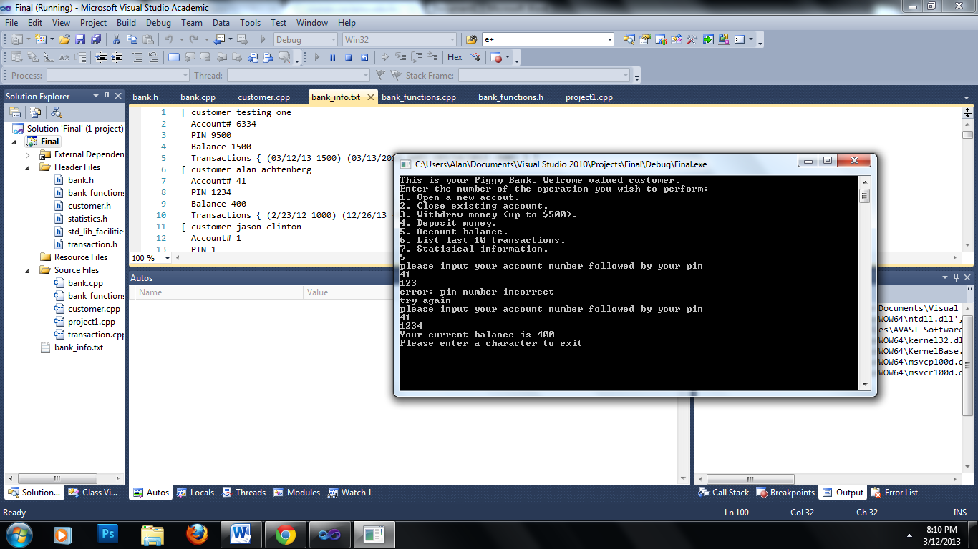

Option 6 allows you to list your transaction history (negative indicates withdraw):

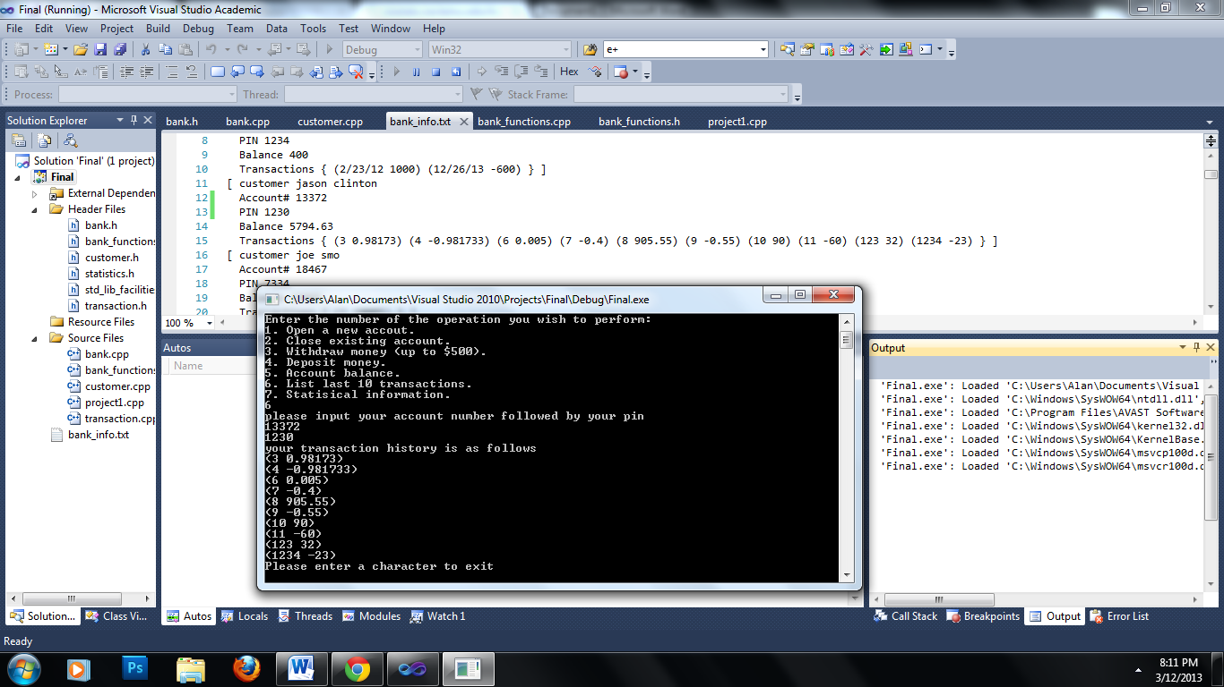

Option 7 gives the statistical information about the bank:

